Solution Requirements
Incident Lifecycle Automation in ServiceNow

1. Purpose
This document records the proposed functional and non-functional requirements for Incident Lifecycle Automation in ServiceNow. The requirements are a baseline for review and should be confirmed before implementation.

2. Functional requirements
- FR-01 — Incident creation: authorised users can create an incident with the required information.
- FR-02 — Categorisation: incident records support the agreed category and subcategory values.
- FR-03 — Prioritisation: impact and urgency are used according to the approved priority approach.
- FR-04 — Assignment: incidents can be routed to an appropriate support group and assigned where applicable.
- FR-05 — Lifecycle tracking: incident state changes can be recorded from creation through investigation, resolution, and closure.
- FR-06 — Workflow automation: selected repetitive steps, such as notifications or routing, may be configured using Flow Designer where suitable and approved.
- FR-07 — Business logic: Business Rules may enforce server-side validation or record behaviour when needed.
- FR-08 — Knowledge support: support agents can search and use relevant Knowledge articles, subject to access permissions.
- FR-09 — Resolution documentation: resolution information is recorded before closure according to the agreed process.
- FR-10 — Related change: when a controlled system change is required, the incident can be associated with the relevant change process where supported by configuration.
- FR-11 — Security: access to incident records and fields follows assigned roles and access controls.

3. Non-functional requirements
- NFR-01 — Usability: forms and status values should be understandable to intended users.
- NFR-02 — Reliability: configured workflows should behave consistently for defined test scenarios.
- NFR-03 — Performance: common incident operations should respond within acceptable limits for the available instance and environment.
- NFR-04 — Maintainability: configuration should be documented and use standard platform features where practical.
- NFR-05 — Security and privacy: access should follow least-privilege principles and approved data-handling policies.
- NFR-06 — Traceability: requirements should map to configuration items and test cases.
- NFR-07 — Compatibility: solution design should respect the ServiceNow release, plugins, permissions, and capabilities available in the target instance.

4. Constraints and assumptions
Implementation depends on the ServiceNow instance, roles, plugins, application scope, and permissions available to the project team.
Existing organisation-specific workflows and policies take precedence over generic examples in this document.
Notifications, assignment automation, and related integrations are included only if configured and tested.
Benefits such as faster resolution or fewer recurring incidents are goals to evaluate, not guaranteed results.

5. Requirement traceability template
For each requirement, record the configuration or design reference, test case, test result, and reviewer approval.

6. Approval
Approved / changes requested:
Comments:

Process Diagram
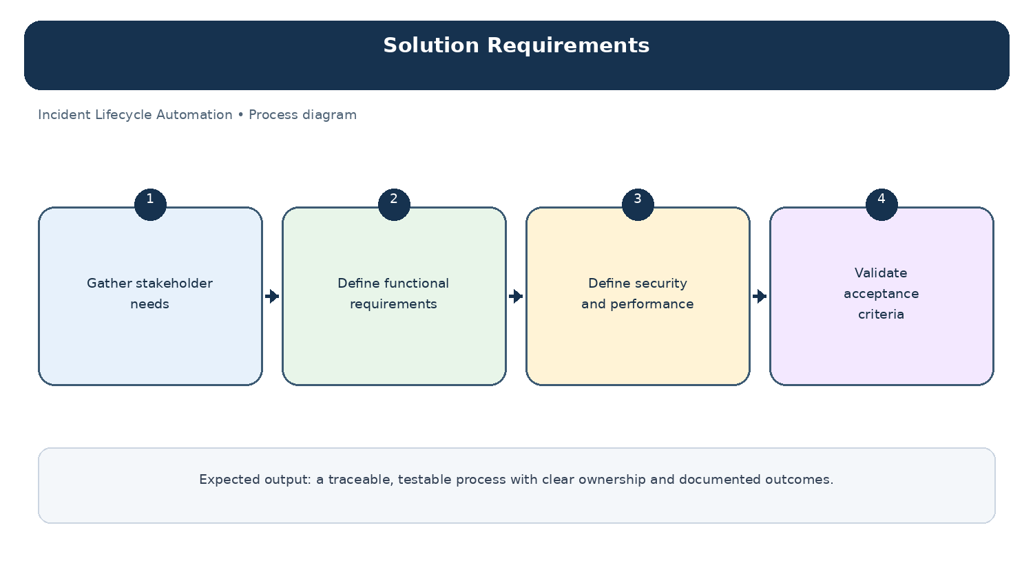
Diagram: Solution Requirements — project-specific process overview.

